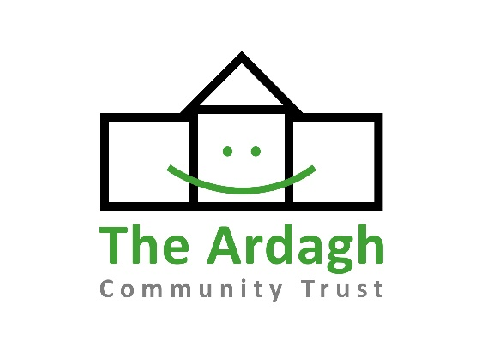

Ardagh Community Trust: Volunteer Equality and Diversity Monitoring Form

We recognise the benefits of a diverse community of volunteers and are committed to being an inclusive organisation where everyone is treated with respect, dignity and where there is equal opportunity for all.

We are committed to eliminating discrimination from our recruitment and day to day volunteering practice. We will take steps to ensure that volunteers are recruited, trained and developed on the basis of ability, the requirement for the role and the need to maintain an effective and efficient service.

To monitor our effectiveness and to comply with the obligations placed on use under equalities legislation, we collect and analyse the following information. All volunteers are requested to complete this form which will be used for monitoring purposes only and will be stored securely.

How to fill in the form

Please complete the form by ticking the relevant boxes and by giving as much information as possible. You can choose not to fill in any or all of the sections and whether or not you choose to do so will have no effect on your application to volunteer with us.

Data Protection

The data you provide is subject to the provisions of the General Data Protection Regulation 2016. By completing this form and returning it to us, whether electronically or by hand, you are giving your permission for us to process the data for equal opportunities monitoring purposes. This information will be held confidentially and will only be used for the purposes of equal opportunities monitoring. All data will be treated as strictly confidential.

Age
Please tell us your age in years:

Gender
Male
Female
Have you ever identified as being transgender? Yes No

Disability
Do you consider yourself to have a disability? Yes No
Under the Equality Act 2010 a disability is described as a physical or mental impairment which has a substantial and long term adverse effect on a person’s ability to carry out normal day-to-day activities.

Ethnicity

White
White Scottish
White British
White Irish
White other

Asia, Asian Scottish, Asian British
Indian
Pakistani
Bangladeshi
Chinese
Any other Asian Background, please write here:

Black, Black Scottish, Black British
Caribbean
African
Any other Black Background, please write here:

Mixed
Any other mixed background, please write here:

Other
Other ethnic background, please write here:
I choose not to disclose

Religion, religious belief or similar philosophical belief
Do you identify with any of the following belief systems?

None
Church of Scotland
Roman Catholic
Other Christian
Buddhist
Hindu
Muslim
Jewish
Sikh
Choose not to disclose
Other Religion, religious belief or similar philosophical belief, please write here:

Sexual Orientation
Heterosexual
Gay man/Homosexual Man
Lesbian/Homosexual Woman/Gay Woman
Bisexual
Choose not to disclose

Comments
I choose not to complete the Equal Opportunities Monitoring Form

